September 3, 2010 - Cary High, known as the first public high school in North Carolina, has a long education tradition.
1871 - Frank Page and community leaders open a school they call Cary Academy. The school is a two-story wood frame structure on Academy Street.
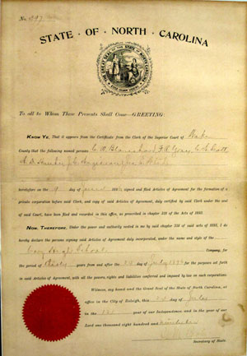
1896 document marking incorporation of Cary High.
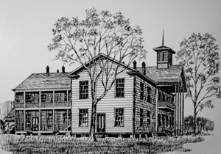
Drawing of 1907 two-story wooden school on Academy Street.
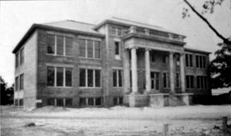
Photo of 1915 three-story brick school on Academy Street.
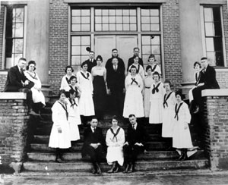
Photo of 1920 Cary High student council at Academy Street school.
1896 - E.L. Middleton hired as the school's principal and the school is incorporated as Cary High School. The document signed by NC Secretary of State C.M. Coolie incorporating Cary High School hangs in the current Cary High School office.
1907 - The General Assembly passes legislation supporting public high schools and eight days after the law is enacted, the school's stockholders sell it to the Wake County Board of Education making it the first public high school in North Carolina.
1908 - Marcus Dry is named the school's principal
1913 - The Cary School District with some assistance from the state replaces the original wood frame school with a brick building
1914 - Dry spends several summers studying agriculture at North Carolina A&M College (now known as NC State University) where he helped to add new curriculum to the school. The school is known as the Cary Public High School and Farm-Life School.
1922 - Walter Hines Page Vocational Education Building provides space for agriculture, home economics and science classes
1925 - James Templeton Physical Education Building permits the basketball team to play on hardwood floor and provides seating for 500.
1927 - First school buses allow consolidation of other Wake County schools into Cary Schools. The Marcus Baxter Dry Building is constructed providing 12 additional classrooms.
1933 - The school ends its boarding program with dorms being converted into living quarters for teachers. The General Assembly assumes responsibility for public schools and ends local district taxing authority.
1938 - R.O. Heater and about a dozen other men organize the Cary Athletic Association to support the school's sports programs.
1939 - Local and WPA funds are used to build a new $132,000 three story school building, the one that currently sits at the end of Academy Street. The cornerstone notes it is the state's first public high school, established in 1907.
1942 - Principal Dry retires. Thaddeus N. Frye is named principal.
1943 - Principal Frye resigns. Earl R. Franklin is named principal.
1947 - The first class graduates that completes 12 years of school. Gov. Broughton speaks at graduation. A memorial service for Principal Dry is held during commencement.
1948 - Principal Franklin resigns. Paul W. Cooper is named principal.
1952 - Wake County Board of Education builds new gym; old gym converted into space for home economics and band.
1957 - Wake County Board of Education purchases 40 acres on the Cary-Macedonia Road (now known as Walnut Street) for a new high school.
1959 - Wake County Board of Education awards J.M. Thompson Construction contract for $771,251 to build the new high school. William Deitrick is the architect.
1960 - Principal Paul Cooper awards 108 diplomas in the last graduation ceremony at the Academy Street school. The 64th graduating class is the first to top 100 students. On Sept. 7, the new high school opens on Walnut Street with 573 students. The Academy Street site remains home to Cary Junior High and Elementary School.
1963 - The first African American students attend Cary High. There are six students: seniors Lucille Evans and Frances Louise White, juniors Gwendolyn Matthews and Brenda Lee Hill; sophomore Esther Lee Mayo; and freshman Phyllis Rose.
1967 - Principal Cooper retires. John Stevens is named principal. Schools are integrated with grades 10-12 at Cary Senior High and the formerly black high school serving as West Cary Junior High with grades 6-9.
1972 - The first mobile classrooms are added at Cary High
1974 - Town of Cary expresses interest in purchasing old Cary High facility on Academy Street. Wake County Board of Education faced with increasing enrollment renovates facility to meet needs of Cary Elementary. At the Walnut Creek high school site, work is underway on a new 8-classroom building and additions to the media center, cafeteria and gym.
1976 - The Wake County and City of Raleigh school systems merge.
1985 - Principal Stevens retires. Dr. Ramey Beavers is named principal.
1989 - A $4.5 million school construction project brings improvements to the school, such as the construction of Building 10. With the addition, the freshman class returned to Cary High for the first since the 1960s.
1992 - Dr. Beavers leaves to become principal at West Lake Middle, the first year-round middle school after being involved in the district study of the issue. Dr. Donna Hargens is named principal at Cary High. At the Academy Street campus, the old Dry Building is demolished.
1994 - KARY-TV hits the airwaves as a student produced closed circuit daily broadcast in the afternoon. The Cary Police Department stations Officer Chris Hoina as the school resource officer at Cary High.
1996 - $3.44 million in school improvements begins to include new classroom and administrative space and A Building renovations for the performing arts department. The Navy establishes a Junior ROTC program at Cary High. The school celebrates the centennial of its founding. On January 4, the landing of a Marine helicopter on campus and a special assembly mark the kick off of the centennial celebration.
The 50-year old Cary High yearbook, the YRAC, captures memories of the school moving to its current location at Walnut Street until that time the Maynard farms tobacco field.
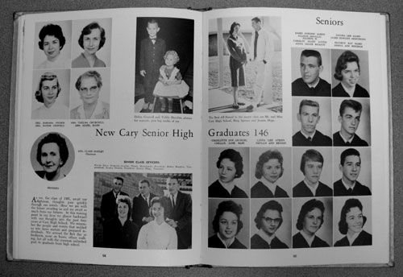
The yearbook has a page headlined "Educator's Dream Becomes Reality." It states that "the doors of a new million dollar Cary Senior High School were opened in the fall of 1960 to 500 eager students."
The yearbook also looks back at the history of Cary High facilities.
1914 - That year saw the first brick building to house the increasing number of boarding g students at Cary Academy. Since 1870, the academy has grown until, by 1913, space was at a premium. As the student body grew, the curriculum expanded. In 1933, consolidation and bus transportation ended boarding school days and brought more students that again crowded the five buildings then on campus.
1938 - Down with the old, up with the new, enlarged building. Still we grew. The years brought additions of a new primary building, gymnasium and cafeteria. The campus now contained eight buildings and lighted football field for night games. The faculty increased from 19 to 52 and the student body doubled in size. As the community grew, so did our educational needs.
1960 - There is a new look to our old love. In the fall of 1960, modern senior high school facilities were opened on a spacious 42 acre campus. Elementary and junior high schools occupy the buildings of the original school site. The curriculum has been broadened to include both distributive education and diversified occupations. The combined faculties total 65. The student body has grown from 200 in 1920 to 2,000 in 1960. And still we grow.
SOURCES: Chronology of Cary High School 1896-1996 compiled by Thomas M. Byrd and Lisa Coston and YRAC 1961, the yearbook of Cary High School.

